**3. Print a paragraph that is a description of a book, include the title of the book as well as its author. Names and titles should be underlined, adjectives should be italicized and bolded. (HTML)**

<html>

<body>

<p>

One particular book which is recommended reading is <u>The Street Lawyer</u> by <u>John Grisham</u>.

This book is about a lawyer who begins re-evaluating his priorities in life when a bad

incident occurs within his law firm. Consequently, he becomes acquainted with the inner city streets, and realizes the harsh existence of the homeless, and vows to give them a chance in the courts.

<u>The Street Lawyer</u> is a <b><i>great</i></b>

book. It is <b><i>well written</i></b> and <b><i>interesting</i></b>.

Other books by <u>John Grisham</u> include <u>The Firm</u>, <u>The Pelican Brief</u>, and <u>The Client</u>.

</p>

</body>

</html>

**Output:**

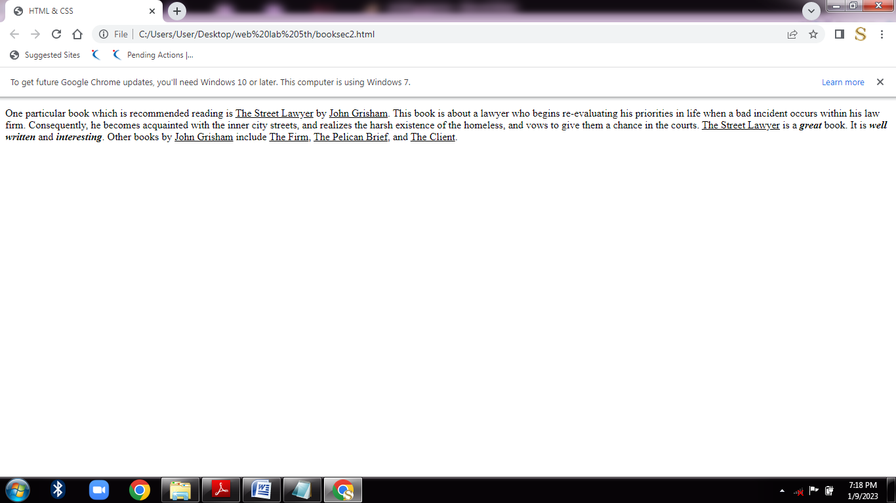

**5. Create links to five different pages on five different websites that should all open in window. (HTML)**

<!DOCTYPE html>

<html>

<body style="background-color:pink;">

<h1>HTML Links</h1>

<p><a href="https://www.w3schools.com" target="_blank">Click Here</a></p>

<h1>Java Prgramming Language</h1>

<p><a href="https://www.javatpoint.com" target="_blank">Click Here</a></p>

<h1>Computer Graphics</h1>

<p><a href="https://www.tutorialspoint.com" target="_blank">Click Here</a></p>

<h1>OOps using C++</h1>

<p><a href="https://www.geeksforgeeks.org" target="_blank">Click Here</a></p>

<h1>Computer Networks </h1>

<p><a href="https://aws.amazon.com" target="_blank">Click Here</a></p>

</body>

</html>

**Output :**

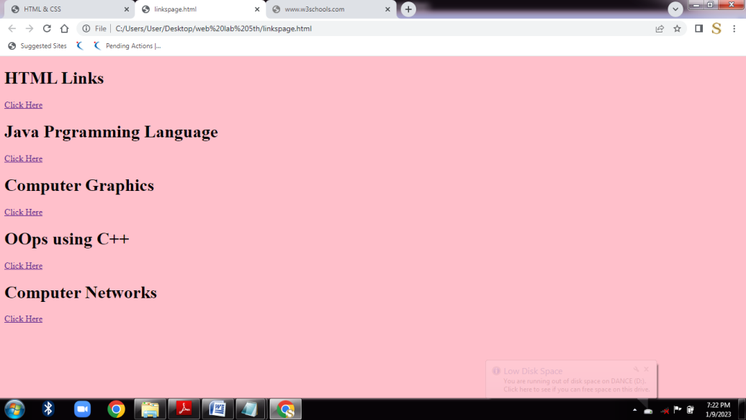

**6. A. Setting a background image for a page Using CSS**

<!DOCTYPE html>

<html>

<head>

<style>

body {

background-image: url('tree.jpg');

}

h1

{

color:white;

}

</style>

</head>

<body>

<h1>This program apply the image on background.</h1>

</body>

</html>

**Output:**

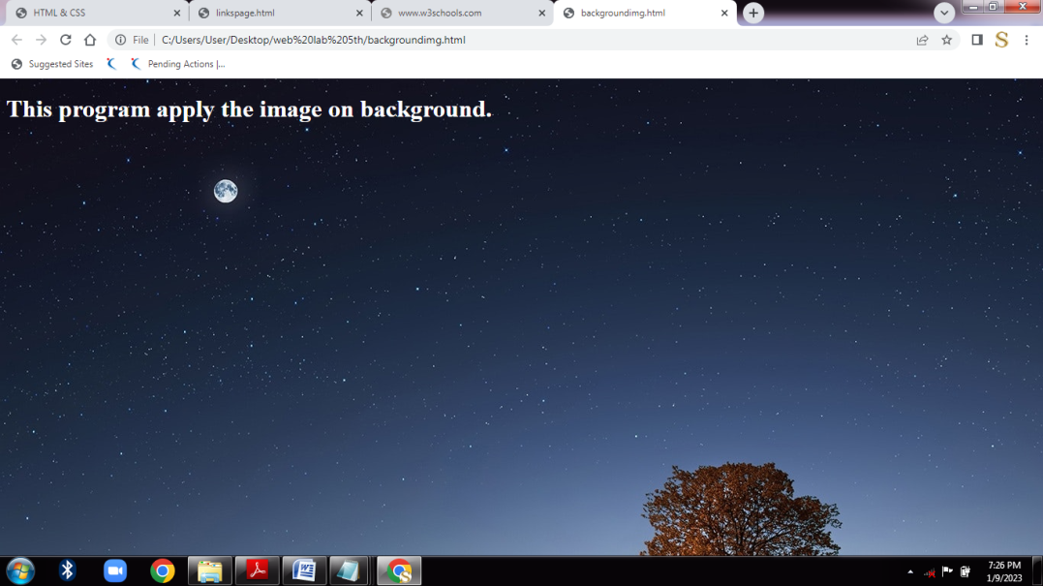

**6 B. Setting text color and background color Using CSS**

<!DOCTYPE html>

<html>

<head>

<style>

body{

background-color:powderblue;

color:black;

}

</style>

</head>

<body>

<h1>Cascading Style Sheets</h1>

</body>

</html>

**Output:**

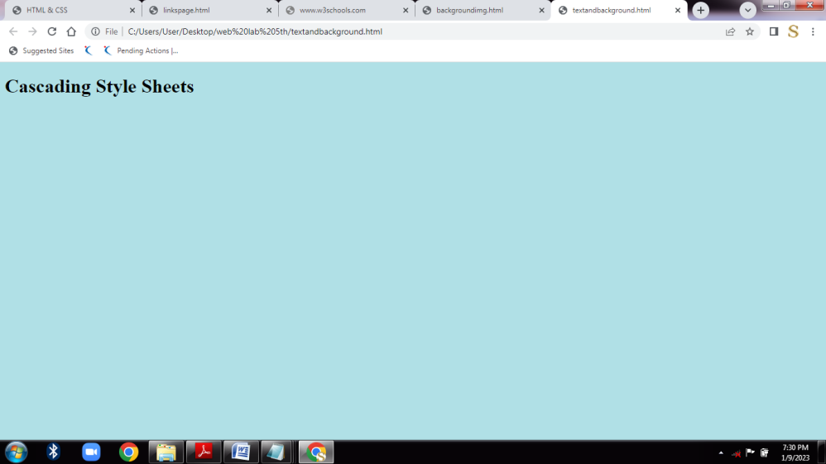

**9. Write a JavaScript program to display the current day and time in the following**

**format. Go to the editor Sample Output : Today is : Tuesday.**

**Current time is : 10 PM : 30 : 38**

<html>

<body>

<script type="text/javascript">

var mydate=new Date();

var myday=mydate.getDay();

var weekday=['Sunday','Monday','Tuesday','Wednesday','Thursday','Friday','Saturday'];

document.write("Today is: "+weekday[myday]);

document.write("<br/>");

var hours=mydate.getHours();

var ampm=hours>=12 ? 'PM' : 'AM';

hours=hours%12;

hours=hours?hours:12;

var minutes=mydate.getMinutes();

minutes=minutes<10? '0' + minutes : minutes;

var mytime=hours + " " + ampm + ":" +minutes+ ":" +mydate.getSeconds();

document.write("\t Current Time is :" +mytime);

</script>

</body>

</html>

**Output :**

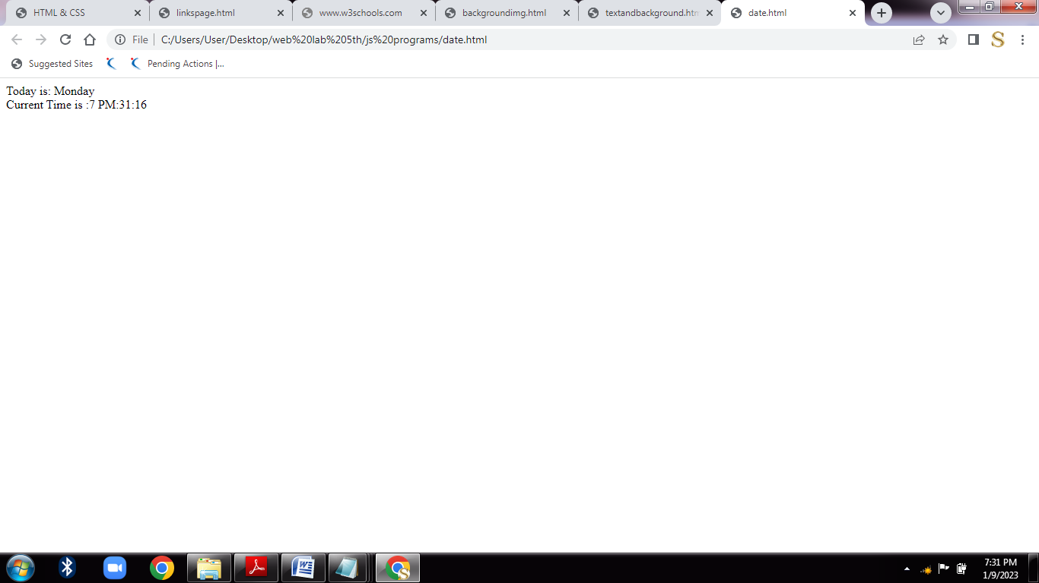

**Write a JavaScript program to convert temperatures to and from Celsius, Fahrenheit.**

<html>

<head>

<script>

function Fahrenheit()

{

var f=1.8*document.getElementById("input1").value+32;

document.getElementById("result").innerHTML=f;

}

function Celsius()

{

var c=(document.getElementById("input2").value-32)/1.8;

document.getElementById("result1").innerHTML=c;

}

</script>

</head>

<body>

<p>Enter Celsius value :</p>

<input id="input1"/>

<button onclick="Fahrenheit()">Convert to Fahrenheit</button>

<p id="result"></p>

<p>Enter Fahrenheit value :</p>

<input id="input2"/>

<button onclick="Celsius()">Convert to Celsius</button>

<p id="result1"></p>

</body>

</html>

**Output :**

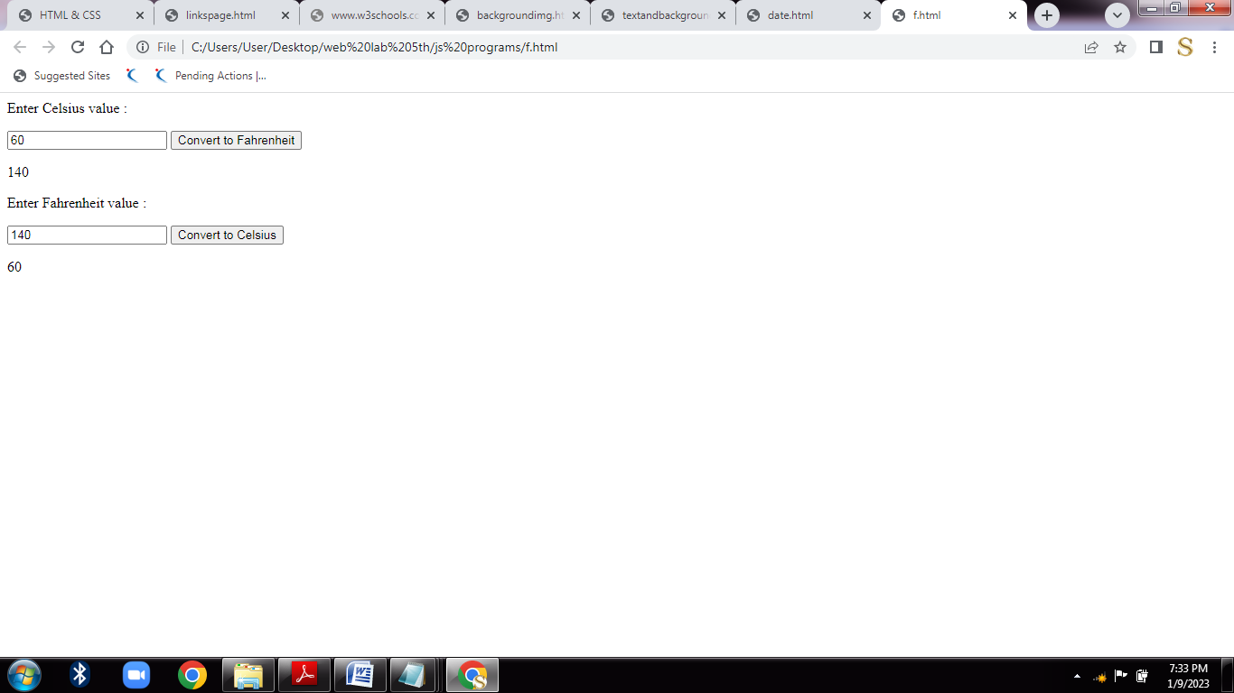

**Write a JavaScript program to find the largest of three given integers.**

**<html>**

**<head>**

**<title>max no</title>**

**</head>**

**<body>**

**<script type="text/javascript">**

**var result=Math.max(648,148,364);**

**document.write("maximum of the given numbers :"+result);**

**</script>**

**</body>**

**</html>**

**Output :**

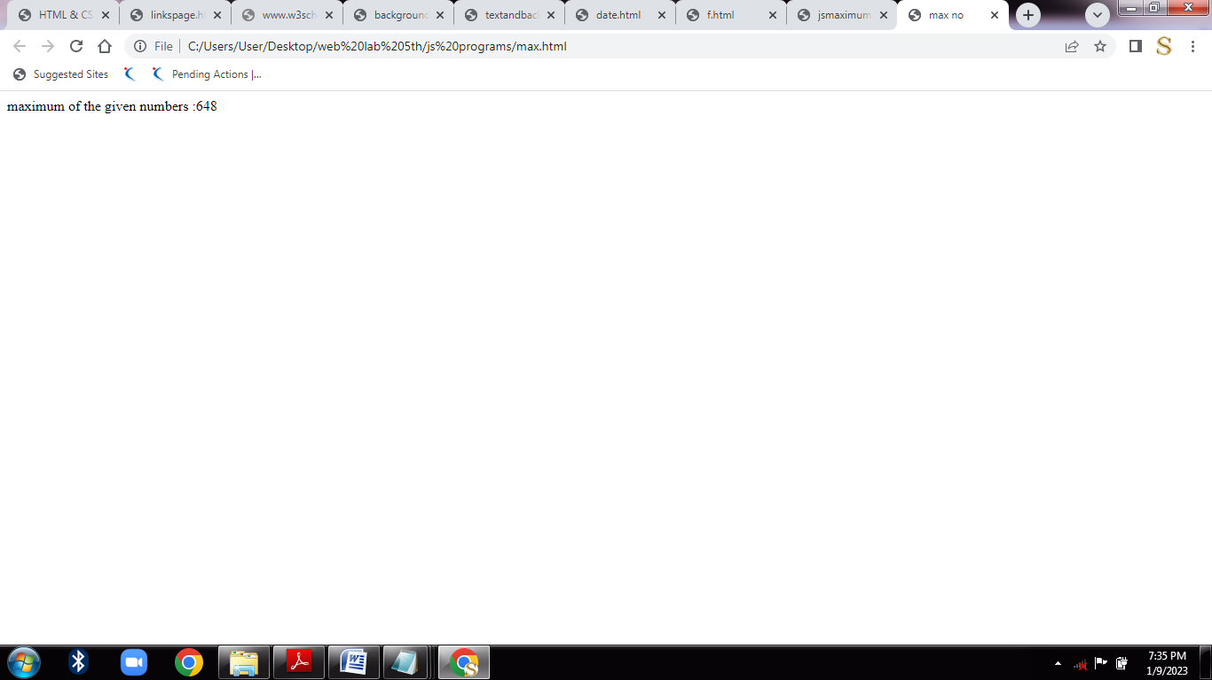

**Create a webpage with two textboxes and command buttons to perform arithmetic operations and display the result in appropriate dialog boxes using JavaScript.**

**<html>**

**<head>**

**<script>**

**var num1,num2,num3,res,temp;**

**function fun()**

**{**

**num1=parseInt(document.getElementById("one").value);**

**num2=parseInt(document.getElementById("two").value);**

**if(num1 && num2)**

**{**

**temp=document.getElementById("res");**

**temp.style.display="block";**

**res=num1+num2;**

**document.getElementById("add").value=res;**

**res=num1-num2;**

**document.getElementById("subtract").value=res;**

**res=num1*num2;**

**document.getElementById("multiply").value=res;**

**res=num1/num2;**

**document.getElementById("divide").value=res;**

**}**

**}**

**</script>**

**</head>**

**<body>**

**<p id="input">Enter First Number :<input id="one"><br/><br/>**

**Enter Second Number :<input id="two"></p>**

**<p><button onclick="fun()">Add,Subtract,Multiply,Divide</button></p>**

**<p id="res" style=display:none;">**

**Addition Result=<input id="add"><br/><br/>**

**Subtraction Result=<input id="subtract"><br/><br/>**

**Multiplication Result<input id="multiply"><br/><br/>**

**Division Result=<input id="divide"></p>**

**</body>**

**</html>**

**Output :**

